Alternate OUs - UX Brief

The purpose of this document is to describe the UX request at a high-level. The document will be used to aid in planning and prioritization of the request.

1. Project at-a-glance

Author of this document | @airsun
Date of last update | 9/25/2024
Project Name | Alternate OUs
Intake ticket | ----
Domain Group | AWS Organizations
High-level description | AWS has launched a new feature called "Alternate OUs" which allows AWS customers to create additional hierarchies within their AWS Organizations, beyond the default hierarchy, so that customers can set up distinct account groups for different management purposes.
Requested by | Andrew Blackham
Submitted on behalf of | Andrew Blackham
Target launch date | Q2 2025
Scope | Medium
Slack channel(s) | #prj-alt-hierarchies-ux
Reference documents
Asana Project | https://app.asana.com/0/1208218179255082/1208218179255094
PRFAQ | https://amazon.awsapps.com/workdocs-preview/index.html#/document/e6c56e8ff4174717b4ee38b4e360e165bd329f3c7ffea00590de86dd694032ee
Figma Design | https://www.figma.com/design/28ddfIO4ecNZciFGOHlmcN/Alternate-Account-Grouping?node-id=1-48&t=XTBX446ZKVmAZVC9-1
Metrics plan
Stakeholders
Product lead (PMT) | Andrew Blackham
Program management (TPM) | ----
Service team SDM | Tauseef Jamadar
Console SDM | Tauseef Jamadar
Eng lead | Mark Meredith
UX designer | James Y. Huntley
UX researcher | @
Tech writer | Daniel Afolabi

2. Schedule and effort estimates
Effort estimations are high-level, and based on the project requirements known at the point in time of writing the UX brief. Completion dates are provided in business weeks and some effort may run concurrently within the same week.

 | A | B | C
1 | Effort and task summaries | Estimate (wks) | ECD
2 | Start date |  | mm/dd/yyyy
3 | CX deep dive |  | mm/dd/yyyy
4 | Kick-off meeting, create User stories doc, create Decisions doc, refine customer stories with PM | 1
5 | Generative research |  | mm/dd/yyyy
6 | Look through past research, discuss customer feeback with PM | 1
7 | UX design |  | mm/dd/yyyy
8 | User flow diagrams and wireframing | 1
9 | Create directional designs [current step] | 2 | 11/5/2024
10 | Align directional UX with stakeholders, partners and SME's | 2 | 11/19/2024
11 | Validation |  | mm/dd/yyyy
12 | Create test plan and collaborate with UX research team and stakeholders | 1
13 | Prepare prototype for testing | 0.5
14 | Recruit participants | 2 | We have 2 weeks to collapse this into (??)
15 | Run tests or conduct interviews | 1
16 | Review findings, synthesize data into a report, share with stakeholders | 1
17 | Finalize UX designs |  | mm/dd/yyyy
18 | Align designs with project stakeholders (PMT, Engineers, marketing, etc.) | 0.5 | 11/26/2024
19 | Align with partner teams |  | 12/6/2024
20 | Review with IDCG UX team and UX leads | 0.5 | 12/13/2024
21 | UX Milestones review and sign-off, accounting for time to make adjustments | 0.5 | 12/20/2024
22 | UX hand-off (date needed by) |  | mm/dd/yyyy
23 | Create hand-off documentation, meet with console and walk through use cases and design specifications | 0.5 | 1/6/2024
24 | Development |  | mm/dd/yyyy
25 | Create metrics plan
26 | Bug bash and dev support | 1
27 | UX Milestones Fit & Finish accounting for time to make adjustments | 1
28 | Total effort and Launch GA | 15.5 | 12/18/2024

3. Current Experience
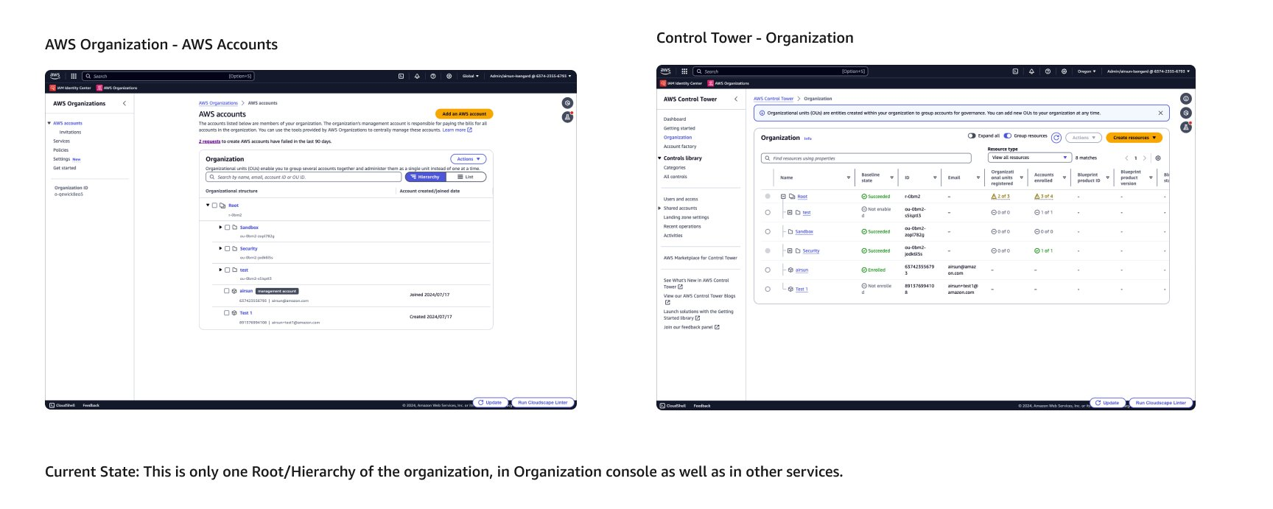

4. Goal and UX scope summary

4.1 Goal
Enable decentralized cloud management and administration:
- Allow customers to empower different teams (e.g. finance, operations, application owners) to manage their own account groups and associated AWS services.
- Provide more flexibility in how accounts are grouped and administered, beyond a single organization hierarchy.
Improve alignment between account groupings and management boundaries:
- Enable customers to create different structure of OUs that better reflect how different teams need to view and manage AWS resources.
- Avoid the need for cloud architects to centrally manage all AWS services if the existing hierarchy doesn't align with team-specific needs.
To measure success, the Orgs team will likely track metrics such as:
- Number of new roots/hierarchies created by customers
- Average number of OUs per customer across their multiple hierarchies
- Increased service enablement on alternate hierarchies (beyond just the default root)
- Feedback from customers indicating improved ability to achieve decentralized management

4.2 UX scope summary
New Workflow & Screens:
- Workflow 1-A: Creating a new root [in Org’s Console];
- Workflow 1-B: Assigning a root when enabling a service [in service Console];
- Workflow 2: Removing a Root in Org’s Console [in Org’s Console];
- Workflow 3-A: Editing a Root Hierarchy (update the alternate hierarchy name) [in Org’s Console];
- Workflow 3-C: Editing a Root Hierarchy (update the attached services) [in service Console];
Enhancing Existing Workflow & Screens:
- Workflow 3-B: Editing a Root Hierarchy (update the alternate hierarchy) [in Org’s Console];
- Workflow 4: Viewing Different Roots [in Org’s Console];

For more detailed information regarding the workflows, please refer to the workflow diagram below:
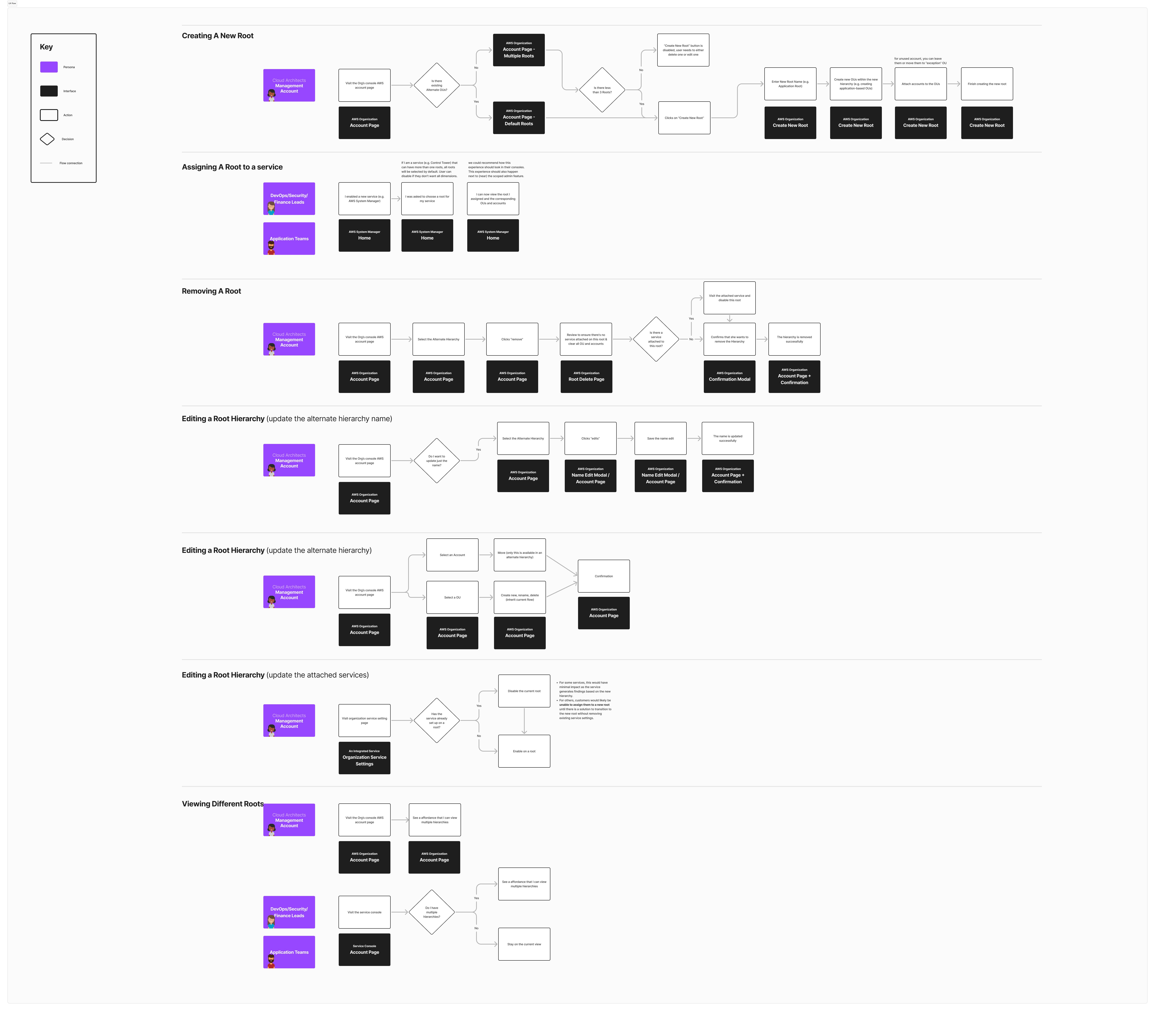

4.3 Projects driving underpinning capabilities
- Scoped Admin: this project will work hand-in-hand with scoped admin where alternate OU will help customers to adopt scoped administration because they can create custom administrative boundaries and assign various delegated administrators for AWS services to OUs.
- Bailiwick
- Orgs widget
- Console X

5. User personas
These are the primary personas that will be directly influenced by the project release. For each persona include a brief 1-2 sentence narrative of who that persona is relative to the project and what they’re looking to achieve with the success of the
project. The below are examples only.

Persona resources: AWS Identity Personas | AWS personas (New)
Image | Persona | Responsibilities | Primary goal | Primary opportunity from project
 | Kelly  Cloud Architects  Management Account | Manages the organization and sets up administrative boundaries for other teams within their business | Create additional administrative boundaries that align with how different teams need to manage accounts, without impacting the existing hierarchy used for security policies.Enable teams to view and manage the account groups (OUs) relevant to the AWS services they are responsible for, without having to manage the entire organization. | Ability to create additional hierarchies (roots and OUs) within the organization to support decentralized management model.Flexibility to set up account groups (OUs) that better reflect how different central teams (e.g., finance, DevOps, security) need to manage AWS services and multi-account features.Opportunity to maintain the existing hierarchy designed around security and policy management, while creating new hierarchies for other use cases (e.g., finance, applications).
 | Sara  DevOps/Security/Finance Leads  OU Delegated Admin | Manage multi-account features and consolidated reporting for the accounts and resources they are responsible for | Gain the ability to manage multi-account features and AWS services within their own dedicated hierarchy, without having to work within the constraints of the central cloud team's existing default hierarchy.Operate independently from other central teams, while still adhering to the overall organization's security policies managed by the central cloud team. | Ability to manage multi-account features and services within their own administrative boundaries, defined by the OUs in the new hierarchies. Visibility and control over the accounts and resources relevant to their team's responsibilities (e.g., finance, security, operations). Opportunity to generate consolidated reports and manage configurations/best practices for the accounts they are responsible for.
 | James  Application Teams  OU Delegated Admin | Manage certain AWS services and configurations for the accounts associated with their applications | Have their own dedicated account groups (OUs) that reflect the application lifecycle stages (dev, test, prod), allowing them to manage services at the application level.Leverage the delegated administration capabilities to perform management and maintenance tasks on the relevant accounts, without requiring involvement from the central cloud team. | Ability to operate as delegated administrators for the OUs aligned with the accounts they own and manage.Ability to manage multi-account features and services within their own administrative boundaries, defined by the OUs in the new hierarchies. Opportunity to have a dedicated hierarchy (root and OUs) for application management, separate from the central compliance and policy management hierarchy.

6. UX narrative (problem and solution)

Kelly, the Cloud Architect, is trying to set up additional hierarchies within her organization's AWS environment to support a decentralized management model, allowing her central teams to manage AWS services and resources based on customized account groups.

6.1 Problem and opportunity
Kelly's organization has grown significantly, with hundreds of AWS accounts spread across various business units and teams. Her existing AWS Organizations structure, designed primarily for security and policy management, does not align well with how her different central teams (finance, DevOps, application owners) need to manage AWS services and resources.

The central teams require the ability to create their own distinct account groups that reflect their specific management needs, such as finance teams managing invoicing and cost sharing, and DevOps teams managing application patching and network settings. However, Kelly's current single hierarchy of Organizational Units (OUs) limits her ability to provide these customized account groups, as accounts can only belong to one OU within the hierarchy.

6.2 Solution
The new capability of additional hierarchies in AWS Organizations allows Kelly to set up multiple root-level structures, each with its own set of OUs. This gives her the flexibility to create account groups that align with the specific needs of her central teams, while maintaining the existing hierarchy for security and policy management.

For example, Kelly can create a "Finance" hierarchy with OUs that reflect her finance team's cost center structure. This allows the finance team to generate cost reports and manage billing features like invoicing and credit sharing at the OU level. Similarly, she can create an "Operations" hierarchy for her DevOps team to manage application patching, network settings, and other operational tasks within their own OU-based account groups.

By leveraging these additional hierarchies, Kelly can empower her central teams to proactively manage the AWS services and resources relevant to their responsibilities, without the need for the central cloud architecture team to manage everything centrally. This decentralized management approach enables Kelly's organization to scale its cloud development and administration efforts more effectively.

7. Research needs (WIP)

7.1. UX research needs

Research needed | Yes | No | Notes
Customer interviews |  | ❌
Metrics / data reporting |  | ❌
Usability testing | ✅ |  | Test the newly enhanced flow and observe the following: 1. The discoverability of this enhanced feature. 2. Whether there are any confusions or blockers when creating/assigning/removing the alternate roots. 3. We are also considering the potential idea of having "templates" for different hierarchies, we should have some visionary prototypes and see user reaction of this idea.

7.2. Description of needs
Since we're investing time and effort into designing and implementing this new experience, we must ensure it resolves current customer pain points without introducing opportunities for abuse.

8. Related links
This is a location to provide documentation that was sourced from in order to provide the context to this document.
- (Andrew) PR/FAQ: https://amazon.awsapps.com/workdocs-preview/index.html#/document/e6c56e8ff4174717b4ee38b4e360e165bd329f3c7ffea00590de86dd694032ee
- (James) UX decisions and questions: Alternate OUs - UX Decisions

